How Often Should you Get a Massage

Massages exist for more than thousands of years, and after an extended period, people have understood the overall health benefits of taking one massage.

From enhancing blood circulation to highlighting lymphatic drainage, there are varieties of massages; and styles and techniques that one can undergo.

With millions of certified doctors and therapists, these massages are practiced and performed efficiently and safely throughout the world.

What health benefits does a Massage offer?

Massages can bring you more health benefits; they help you to relieve chronic pain, lower blood pressure, improve the sleeping time, and reduce stress effects. Other than that, it helps provide a speedier recovery from any injuries, capable of optimizing an athlete’s game and much more. You can take this massages depending on your lifestyle, goals, your health state, etc

There are a lot of massagers like foot massagers, neck massager, shoulder massagers and much more that can benefit you as per the situation and condition you are in.

Relaxation and Wellness

Massages can be taken even by the healthiest person around too.

Even the healthiest person around can take a massage. What can massages benefit in the healthiest person? benefits can it possibly provide?

- Enhances Blood Circulation
- Calm the Central Nervous System
- Broaden tight muscles
- Boosts Immunity
- Eliminate the toxins from the tissue by loosening

Even the healthiest person will feel the strain on a stressful day at the office or any other areas. In this case, a massage helps in enhancing ones health and providing an active feel over the entire day without fail. Schedule a massage two times in a month to enjoy the overall benefits.

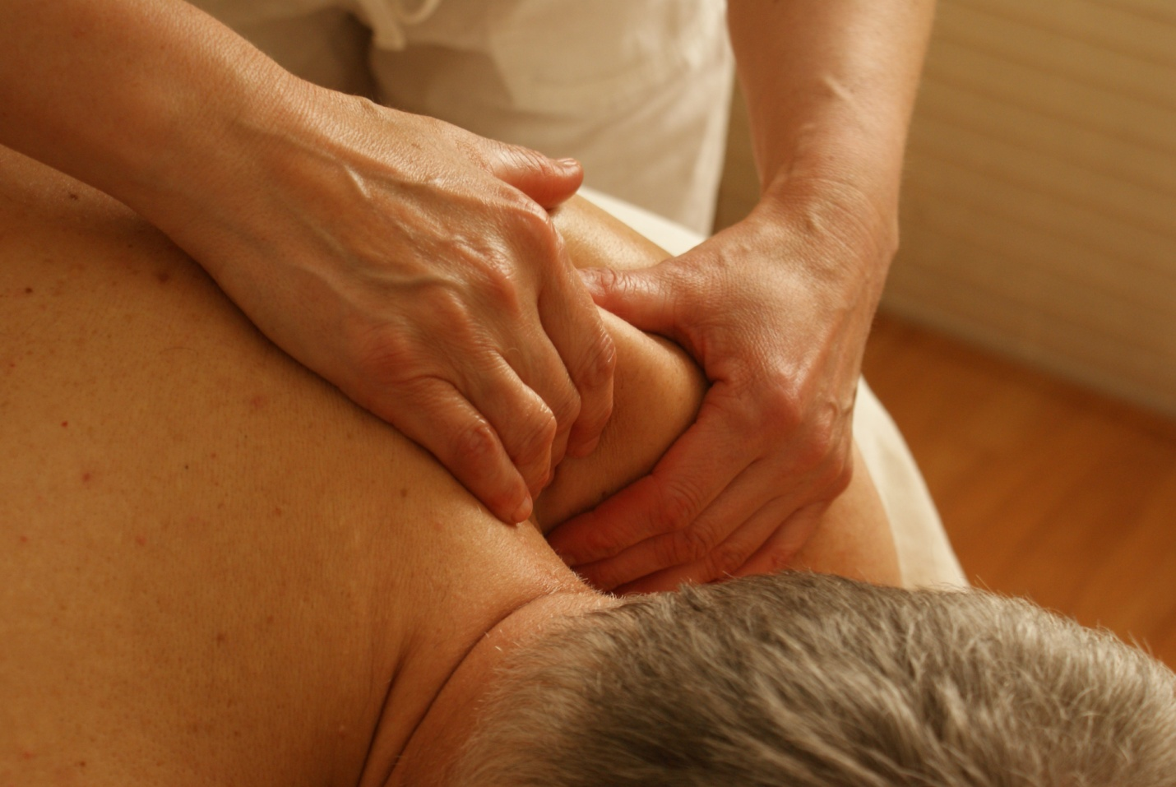

If you are the one who works in an environment that induces over excessive strain, then you can take massages regularly for performing your daily activities and risky actions successfully.

Massages for Enhancing Performance in an Athlete

For sportspersons, a massage will be is considered as highly useful in improving their performance and to reduce the an injury risk by increasing joint mobility and balancing muscle groups. It's good to take two or more sessions of massages for sportsmen to stay in top great shape. and Additionally, to most of the most professional sports teams often will have therapists who can treat them if some muscle contraction or other problem occurs while undertaking performing any sports activities.

Based on the a training schedule, an average sportspersons can take massages; it's advised to take two to three massages in a month for increasing the frequency as there could well will be high risks and stressful workouts included.

Here’s an important factor to consider

Make sure you are not taking the deep tissue massaging technique before five days of any significant event as there are high chances for changes and soreness in the body while performing sports activities.

You can take Abhyanga or Swedish massages before or after an event as these massages only increase the even blood circulation throughout the body.

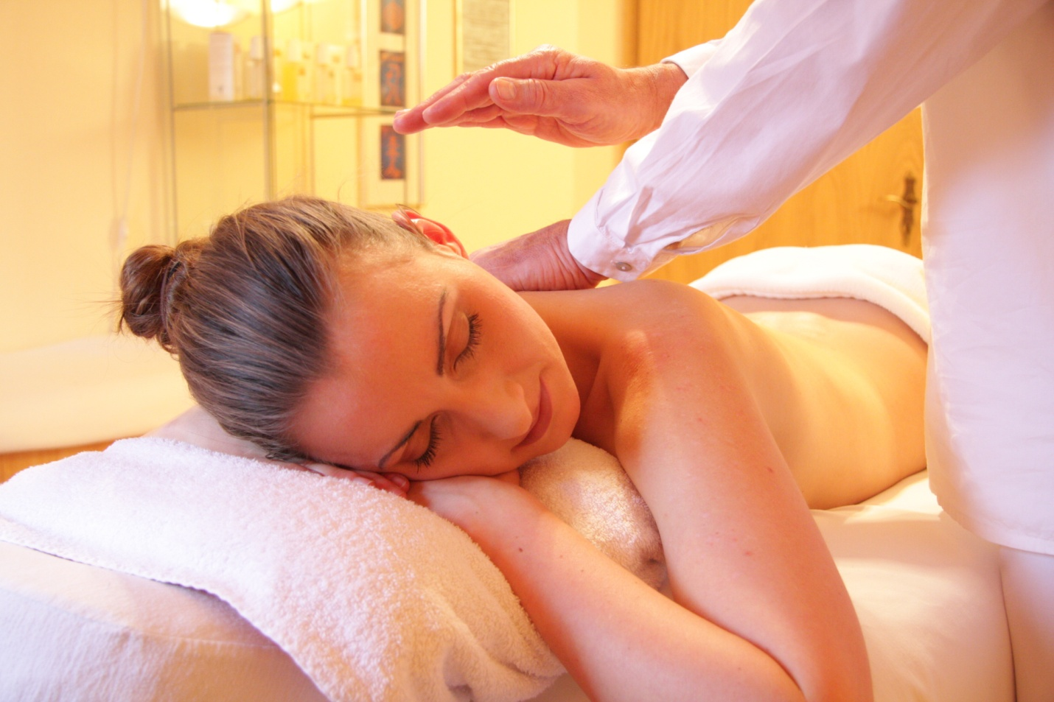

Recovering from a Surgery or Injury

Massages help in treating and getting speed recovery from surgeries or injuries. It helps They help in minimizing the pain causes, decreasing swellings, break ups of the scar tissue, enhancing the flow of oxygen and blood and, in fastening the healing process so that one can return to normality.

Make sure to choose the massages after getting a consultation with your doctor as there are few massages are not deemed suitable for some medical conditions. For example, a deep tissue massage will not help a person with an acute injury or for the blood thinners, so you can ask your doctor for the best massaging techniques that are best for your medical condition.

Once you have chosen the desired massaging style, you can take it one or two sessions in a week for the hasten the recovery speed.

Pain Management

Muscle contraction leads to chronic pain namely sciatica, migraine and much more, in this case, doctors and therapists recommends weekly sessions as per the pain condition.

If you think your pain returns within few days, then it means you need to be ready for the next massage session. Few of the therapists will advise you to undertake stretching exercises at home so that they will be able to maintain their muscle balance to a longer core between sessions.

What about the affordability?

Taking massages in routine would may cost around $65 to $150 per hour, and this depends on the place you are living, your doctor or therapist qualifications. You need to be careful while selecting a therapist; make sure they are experienced and certified one . Additionally, check the hours of training they performed.

Selection of a wrong therapist can could result in injuries, and you won't have the satisfaction and the overall benefits a massage could normally provide. Few spas, reputed practitioners, and wellness centers provide package deals, membership plans with offers and discounts.

Author’s Bio

Mohammed is a leading massage therapist who runs a group of spas in the United States. He writes on various topics in his blog massagerland.com

